**Project Name:** Paryatan Tourism Management

**Github Link:** https://github.com/projectsforstudents2022/Paraytan_Tourism_Management.git

**Why was this project created?**

The majority of individuals in our world like traveling, whether it is across short distances or long ones. Every tour management firm is looking for a tourist management system that can manage tourism information easily. A dynamic website for the tourist industry is called the tour management system. Travel agencies may handle various tour packages based on the destinations with the help of this travel and tourism application. Using this, the travel agency may create custom travel packages that cover a range of locations and pricing points. The administrator may easily locate and update or upgrade the tour packages thanks to the search module that was also included.

**What problem is it solving?**

This project's goal is to create a system that streamlines the operations and procedures of a travel business. To correctly design and execute a certain journey is laborious for the consumer. This project was created to replace the present system, which assists in keeping track of client information regarding destination and money received. The highly automated technology under consideration makes traveling considerably more convenient and flexible. Users may obtain the most pertinent information at the most appropriate moment. As a result, the consumer will have more faith in the travel agency.

**Entire explanation of project**

* **PROPOSED APPROACH**

The three essential components of the entire programme design are the WebUI, the middleware layer, and the persistence layer. A tourism manager may add new visitors and edit or delete their personal information using this project. Additionally, it contains a search function that allows the assistant to look for tourist names according to their starting and ending points. The information is kept in a MySQL database. The database consists of two tables. Data of a tourist refers to information such as an ID, name, starting and ending locations, the number of days, and the cost of a tour package that is entered into a table called tour package with an ID as the primary key. The admin may change the information about each visitor by using the user table, which contains information like username and password for login.

The back end for this project is SQL Server. All of the data will be kept on the server, which also has a backup copy of the data in case of data loss. Each part of the visitor will have its own information available. The admins only need to click once to access all the information.

* **DATA FLOW DIAGRAM**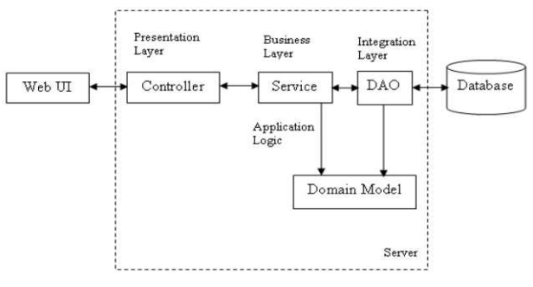
* **RESULT**

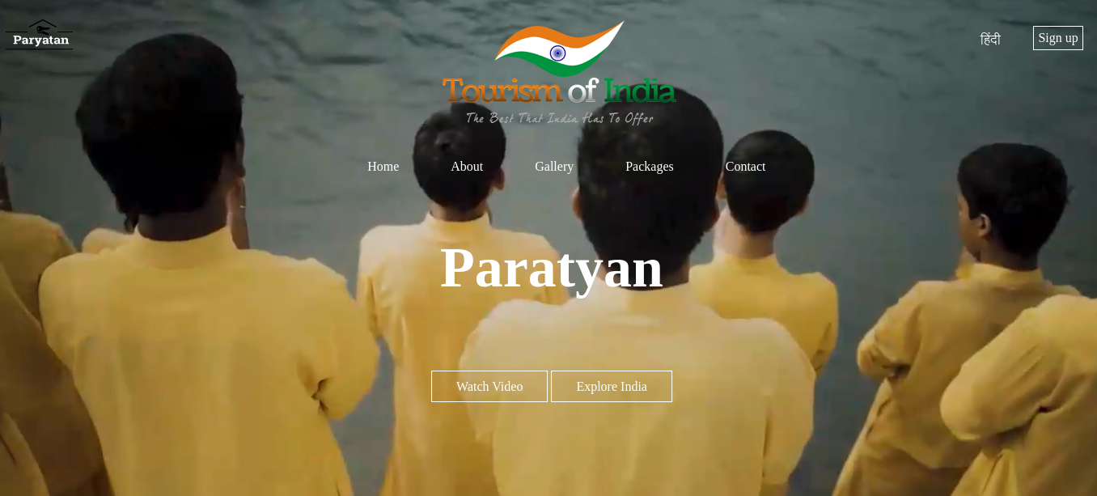

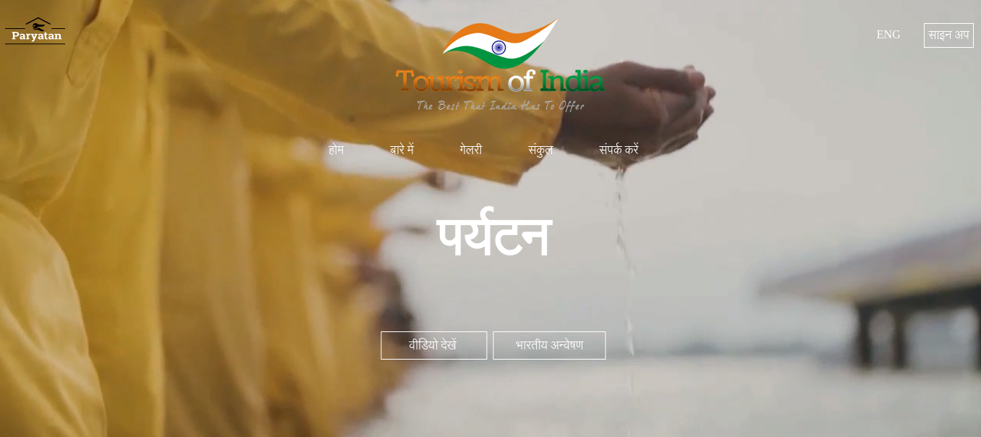

* **CONCLUSION**

Currently, tourism is acknowledged as a major worldwide business that is expanding quickly. The core of tourism is having access to pertinent and reliable information. By documenting what a visitor deems important, the suggested project on Tourism Management System attempts to close this gap. As a result, the goal of this project is to build and execute a platform that will let travelers have access to travel to different tourist destinations. The project also provided information on client server technology, which will be in high demand in the future, as well as the most recent technology utilized in creating web-enabled applications.